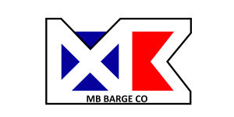
P.O. Box 11457
Pensacola, FL 32524
(850) 255-5266

MB Barge Co. proposes the 240’ X 72’ X 15’ Ex-ABS deck barge “CB-5” for any of your upcoming projects. Attached are some of the original ABS drawings and photos of work being performed to ready it for service. Note that sections of the side-shell have been removed to facilitate cleaning, repairs and coating of the internal structures. All removed side-shell has been replaced except 2 locations where spud-wells are being accessed. Charter rates are subject to area and type of operation and length of charter.

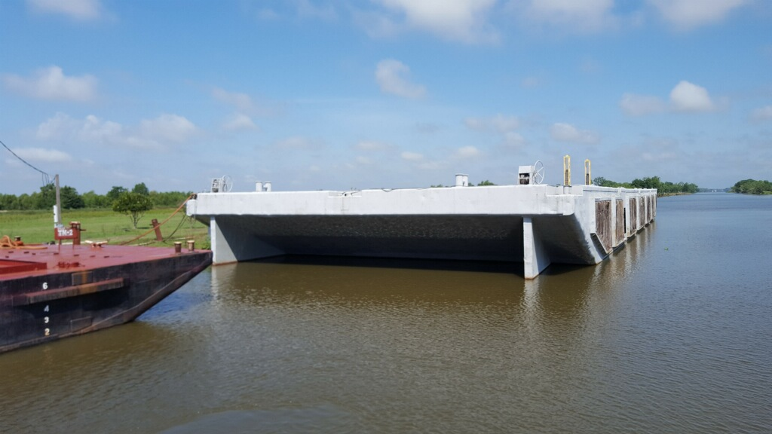

BARGE “CB-5” GENERAL PARTICULARS
Hull Material | Steel | Year Built | 1982
Length (LOA) (Ft) | 240’ 00” | Hull Depth (Ft) | 15’ 00”
Hull Breadth (Ft) | 72’ 00” | Light Draft (Ft) | 2.5’
Loaded Draft (Ft) | 12’ w/3’ Freeboard | Gross Tonnage | 2253
Spud Wells (2) | 3’4” X 3’4” Clear I.D. | Net Tonnage | 2253
Spud Legs (2) and Hydraulic Winches | 80’-110’ x 37.5” Steel Heavy Steel Spuds | Winches (2) | 75 Ton Line Pull Hyd. Single Drum w/HPU
Classification | Ex ABS Oceans | Coated Internals | Yes
Fendering | Wood/Earth Mover Tires | Towing Skegs | Yes

SPUD SYSTEM CONVERSION
The CB-5 is currently undergoing a conversion into a deep-water spud barge with 2 ea. Single Drum Winches. The spuds will be 37.5” X 37.5” outside measurements and 80’-110’ long constructed of 1” plate and 8”X8” X 1” angle corners to form a square spud. The spuds and spud wells were engineered by Shearer and Associates out of Houston, Texas. This extra spud length and high capacity winches will give the CB-5 unique capabilities as a work platform ideally suited for deep channel and harbor construction projects (50 feet + MLLW).

MOORING SYSTEM OPTION
As an added optional feature, a 4-point mooring and anchor system can be installed to secure the barge in lieu of the spud system for higher current or deeper water applications. For this application, two Skagit DMW150 Double Drum Winches would be installed fore and aft (below deck). These winches have a first layer line pull rating of 279K# per drum. 2 inch cable would be run through fairleads on the bow and stern to secure the anchors or tie off to an existing anchor set and/or buoys.

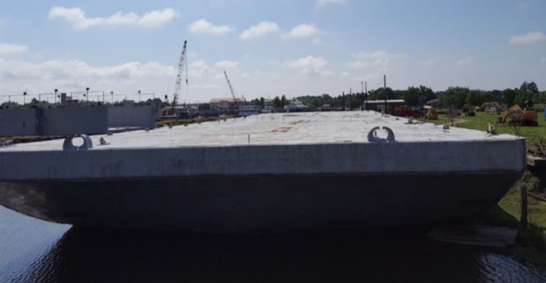  Bow View | 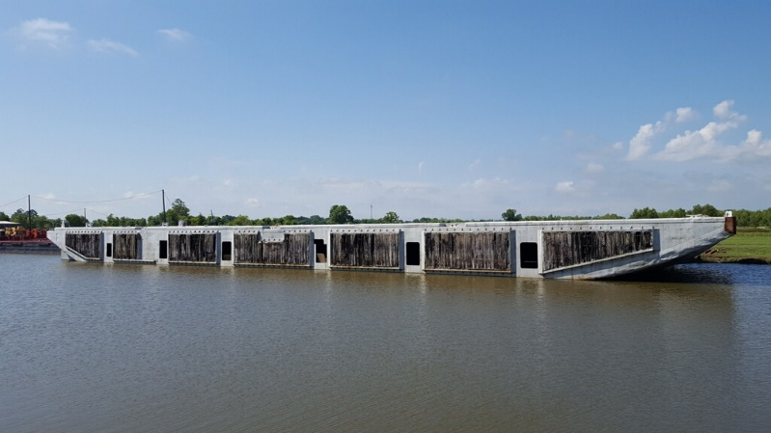  Starboard Side Shell
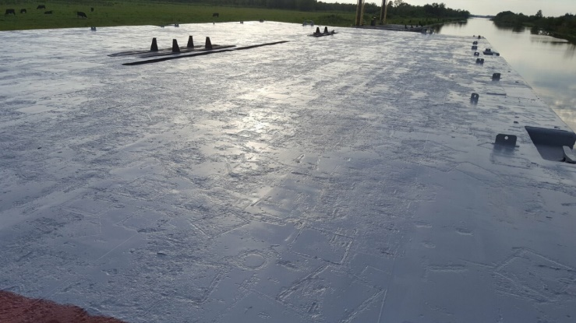  Main Deck | 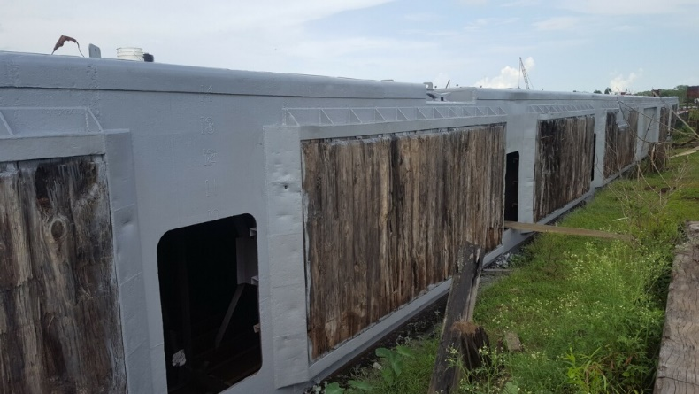  Port Side Shell
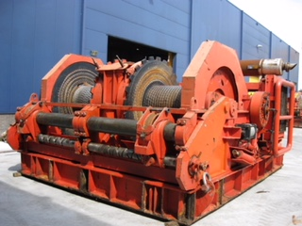  Skagit DMW 150 Anchor Winches | 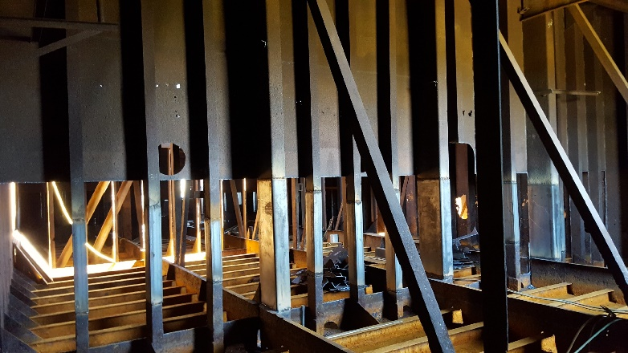  Internal Repairs
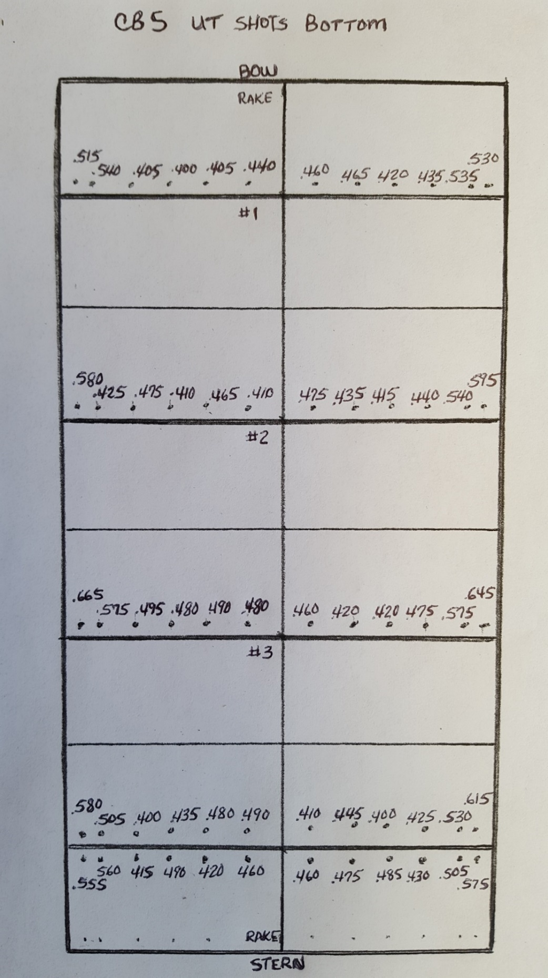
Hull Bottom Thickness Readings (January 2018)

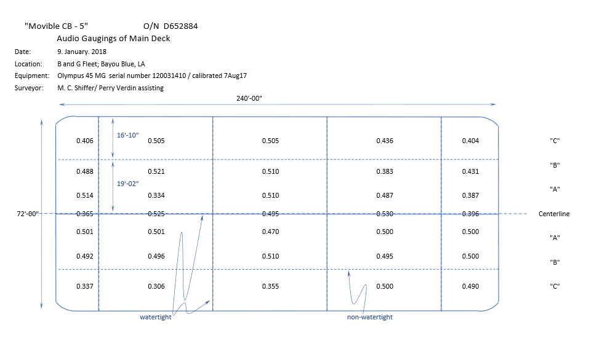
Deck Thickness Readings (January 2018)

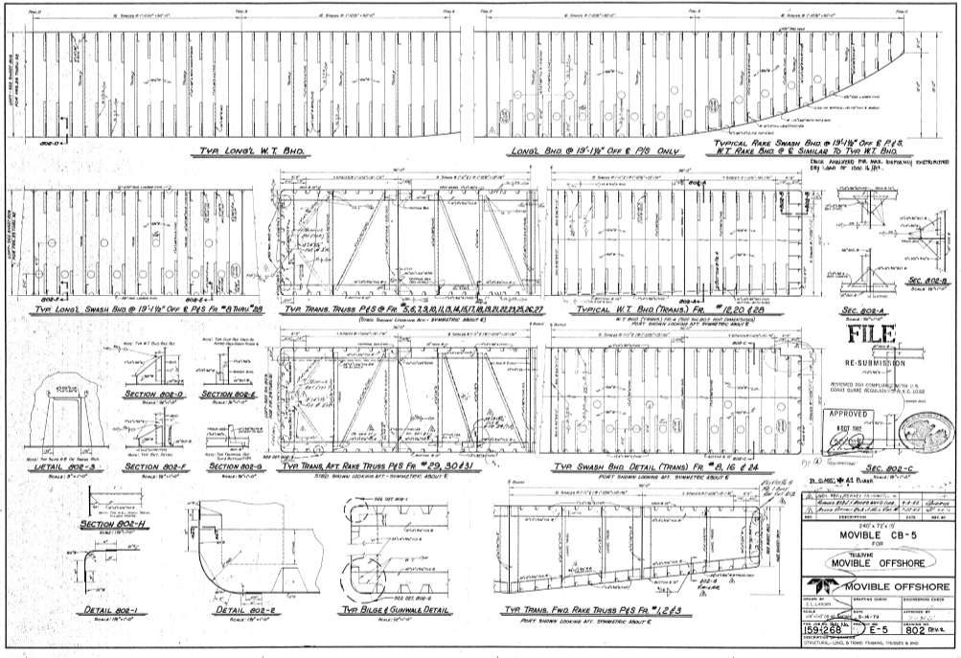
ABS Drawing (Framing Layout)
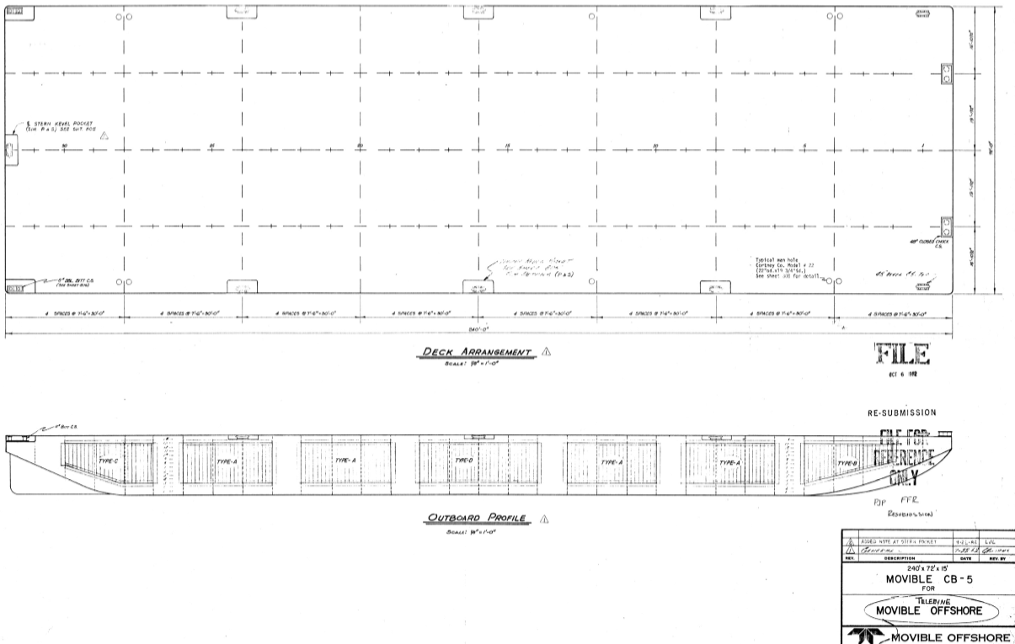
ABS Drawing (General Deck Layout)
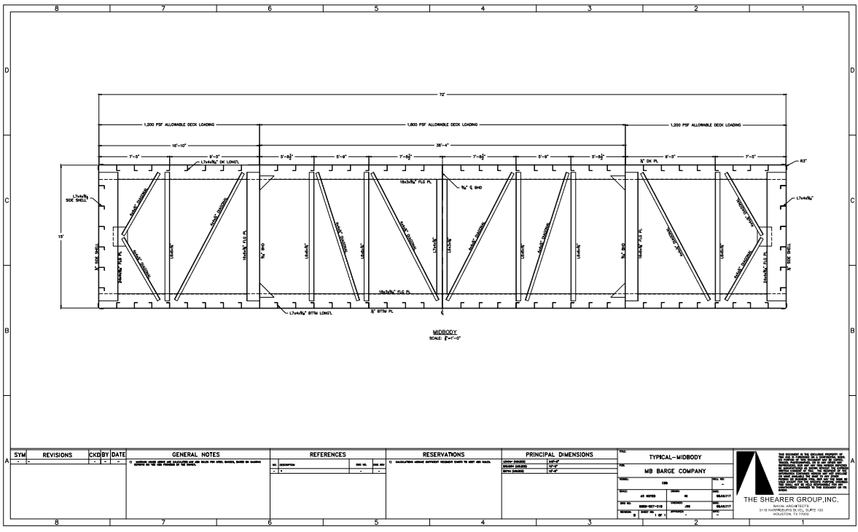
Mid-Body Layout (NEW)

